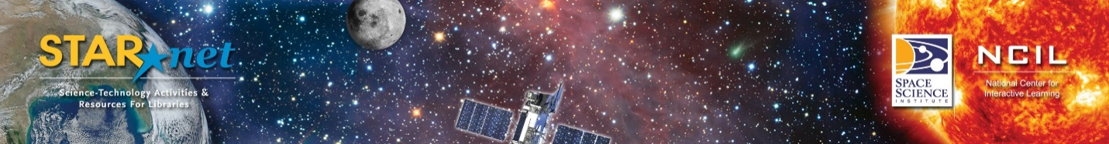

Community Dialogues Reflection Report

- Date/Time

- Location

- Names of Organizers/Facilitator(s)

- Number of attendees

- What institutions/organizations/individuals were present at your event?

- What community groups or audiences did you target for this event? (For example, homeless populations, ethnic groups, etc.) Did they attend? If not, what will you do next time to encourage their attendance?

- What strategies did you use to recruit participants (for example, a flyer, email, phone call, etc.)? Which were most effective?

- What did you hope to achieve for your library and community through the Community Dialogue event?

- What were the key takeaways from the discussion?

- Which potential collaborations are you most excited about? Why?

- What are your next-steps/plans to follow-up with participants?

- In what ways do you feel that the Community Dialogue framework is effective for reaching underserved audiences?

- Would you conduct another Community Dialogue? Why or why not?

- Do you have any Community Dialogue “hacks” that would be useful for others conducting these conversations?

- Can we use this information to create Community Dialogue examples for other libraries?

Please email this form (and any pictures we can share from your Dialogue) to Anne Holland (aholland@spacescience.org)

